February 2023

**NEWS IN YOUR AREA**

**Frome Town**

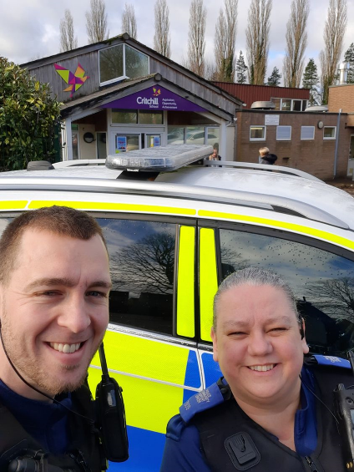PCSO's Kris Seviour and Shelley Day attended Critchill school this month delivering an input on all things Police. They thanked all the students from the reception class for raising such good questions on the day, we are always happy to come and have a chat about anything. PCSO Kris was even set a challenge by one of the students on how many police hats he could put on his head! If you would like to speak with a member of your Neighbourhood Team to arrange a talk then please contact us and we would be happy to discuss your requirements.

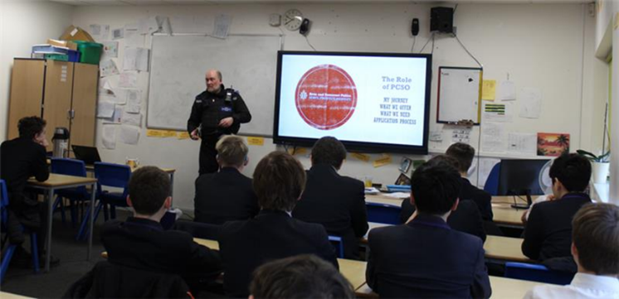PCSO Gary Maule was invited into Frome Community College this month on their careers day to talk about the role of a PCSO and what Avon and Somerset Constabulary has to offer. Gary is a very experienced PCSO with 16 years of experience behind him. He was very happy to deliver a talk when approached by the school.

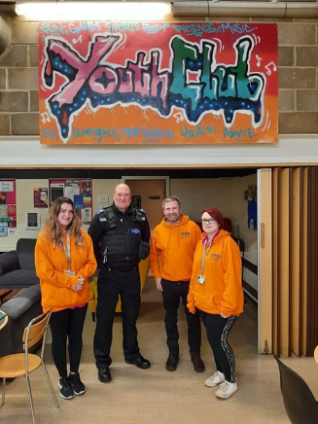The Frome Neighbourhood Policing Team were made aware of intelligence concerning a vehicle driving around with no tax, no insurance, and no MOT. Officers have now removed the vehicle from the highway for causing obstruction the vehicle was spotted by PCSO Shelley Day and PCSO Gary Maule. Facebook is a great tool for us all to communicate and share information, but without an official report to the Police these are the kinds of occurrences that have the potential to carry on, unnoticed. Contact can be made via 999, 101 or the online reporting process.

PCSO's Gary Maule and Kris Seviour attended Vallis youth club on Monday evening to say hi to the many young people that attend. They were able to catch up with youth leaders Chiara, Dave and Lucy who run the youth club and were told of some exciting developments that will be unfolding for the young people of Frome in the coming weeks.

PCSO Will met up with our Park Rangers this month. The town council are recruiting two further Rangers and advise you to take a look on the Town council website for more information. As a team, we wanted to thank them for all the hard work they do which allows all of us to enjoy our beautiful green spaces.

As Neighbourhood Officers we are always keen on developing good working relationships with local agencies.

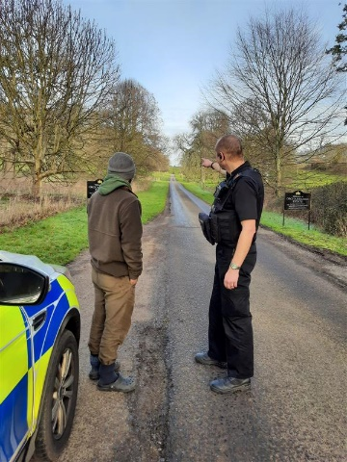**Frome Rural**

Lately we have had several reports of poaching in the Frome rural area. We are interested in all reports of wildlife and rural crime and suspicious incidents. Reports received from the public will help inform the patrols we conduct during this poaching season. We are always available to visit your farm or rural property to discuss Farm Watch, crime prevention and any other community issues. You can report a crime online or call 101 (for non-emergencies) or 999 (for emergencies). Alternatively report a suspicious incident to your Farm Watch, or Horse Watch representative.

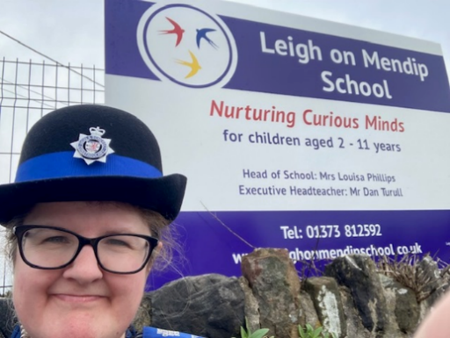PCSO Mandy attended Leigh on Mendip School this month to deliver a talk on stranger danger / internet safety with the pupils. It was a fun and great learning experience for all.

Your Neighbourhood Team would like to take this opportunity to remind you that February was Internet Safety Month!

We will be conducting various talks about internet safety to students and other young people as we cannot stress enough how important it is to keep yourself, your friends, and anyone else you know safe online.

**Shepton Mallet town have had a new member join the team, PCSO Rebecca Manley. We are delighted to have extended the team again allowing us to cover a bigger area around Shepton Town with more visibility. Beccy has joined us from Bath outer neighbourhood team, where she has worked for the past two years.

PCSO Rich Riley has completed some excellent partnership work with Whitstone school, working with the school has allowed us to do more one-to-one work with the students. Rich and Jake have also attended the school’s parents evening, where they set up their own stand showing the application process and different career options for students looking for a career within A&S Constabulary.

PC Chris Norris has been covering both town and rural beats dealing not only with neighbourhood jobs but has also been helping our response colleagues at Shepton as well. Chris has focused recently on our more vulnerable people within our beat, this consisted of contacting and visiting people who may struggle with disabilities, daily struggles or mental health issues. From these visits we can sign post or refer people to help them get the correct support of which they need.

Not only do we speak with our victims reference the crimes they have reported to us but we also spend a huge amount of time contacting and speaking with our housing officers within Shepton on other solutions that we can collaboratively work on together to help reduce crime in the area.

Both the Shepton and Frome neighbourhood teams have helped and assisted our colleagues in Glastonbury recently helping out with high visibility patrols and scene preservation related to an ongoing investigation that took place in the town.

**Shepton Mallet Rural**

The rural Shepton team have been extremely busy this month investigating theft of plant equipment across the beat area. Theft of plant is on the increase which means that the team has been adapting commitments around these times and places. PCSO Thompson has been signing up farmers and landowners which have stock or farming equipment, to Farm Watch which is a similar scheme to the Neighbourhood Watch. This allows the police and the community to work together along with intelligence to gather a bigger picture on what is happening in that area. We are lucky enough to get Selecta DNA which is a unique DNA marking resource which can be used on over 100 different bits of equipment, we also give this to some of our community who have been at risk, or affected by rural theft.

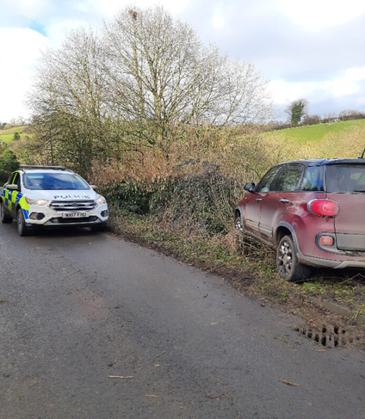 PCSO Thompson and Tailby have worked on some intelligence which was given to the team by our response colleagues concerning a stolen vehicle. The team managed to find the vehicle which was left damaged in a hedge in one of the villages on the beat. The vehicle was returned to the owner and the suspect was dealt with by investigations and response for the theft of vehicle.

**LOCAL EVENTS FOR YOUR DIARY**

**Avon and Somerset Police website**

Keep up to date with our engagements and appeals on our website.

<https://www.avonandsomerset.police.uk/your-area/>

Bike Marking

Details of future Bike Marking events can be found on our Social Media channels or also via our Avon and Somerset Police website.

<https://www.avonandsomerset.police.uk/your-area/>

Keep up to date

Facebook and Twitter are a fantastic way to keep up to date with your local Neighbourhood Policing team. Follow us on:

**Facebook:** Frome Neighbourhood Policing

Mendip Neighbourhood Policing

**Twitter:** @ASPMendip



**Get in Touch**

**In an emergency always call 999**

**For non-emergency matters call us on 101** or report online via [www.avonandsomerset.police.uk/  
report](http://www.avonandsomerset.police.uk/report)

**To report a crime anonymously,** contact Crimestoppers on 0800 555 111 or visit

[www.crimestoppers-uk.org](http://www.crimestoppers-uk.org)

**CONTACT US**